**"From the Life of Planets”**

**A musical homage to movies of the 1960s that were never made**

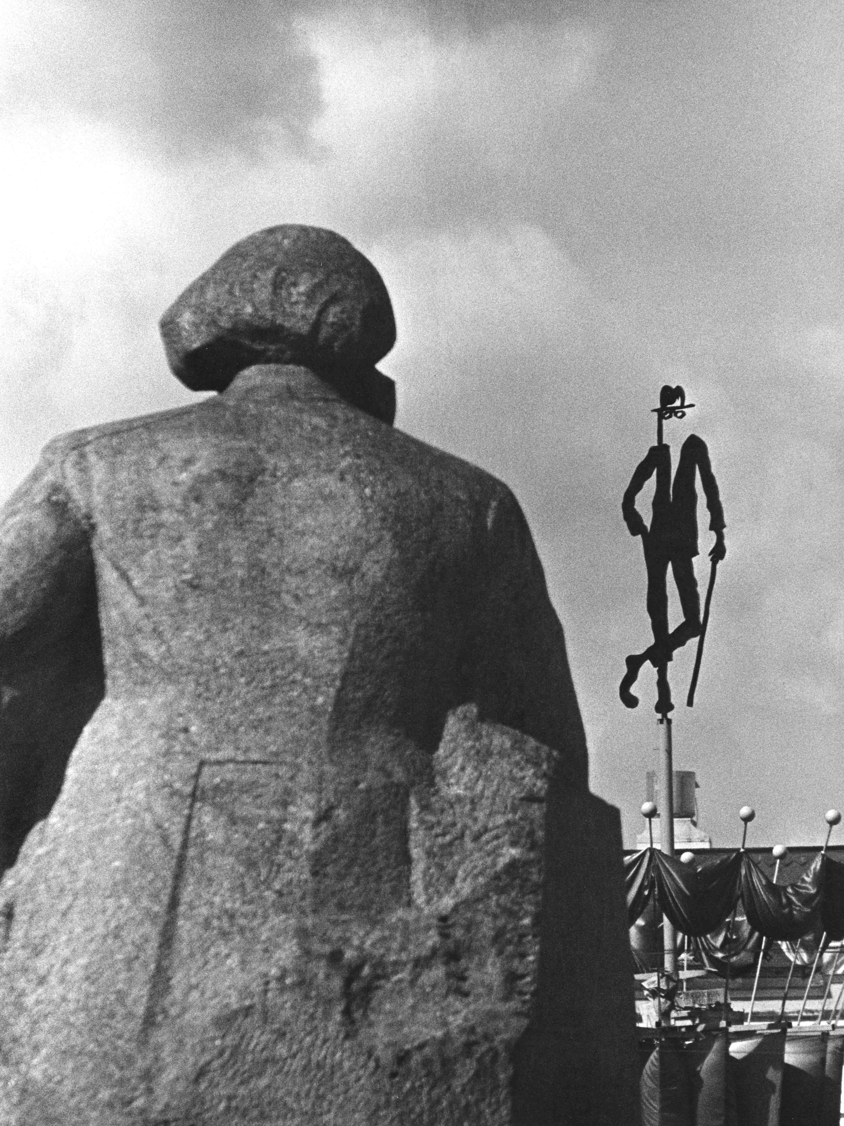

**History**   
  
“From the Life of Planets” is a musical tribute to Russian films of the 1960s that were never made due to the changing political climate. Known as “the Thaw,” the period from the mid-1950s to early 1960s was a time of relaxed repression and censorship in the culture and life of Russia, the sudden breath of freedom.

A new cinema was born -- a Soviet New Wave -- with one breakthrough followed by another. Russian films saw international recognition by the Cannes Film Festival ("The Cranes are Flying" -- grand prix, 1958; "The Ballad of a Soldier" and "The Lady with the Little Dog," 1960; "The Story of the Flaming Years," 1961; "The Optimistic Tragedy," 1963; "Lenin in Poland," 1966) and the Venice Film Festival ("Peace to Him Who Enters" -- gold medal, 1961; "Ivan's Childhood” – grand prix, 1962; "Introduction to Life," 1963; "I'm Twenty" and "The Fidelity," 1964). It was a true golden age of Russian cinema...

But suddenly it was over. Freedom turned to unfreedom: At Mosfilm movie studio alone, 12 film projects were shut down in the autumn of 1963, and by the end of 1968, after Soviet suppression of the Prague Spring, the new cinema had become a sprawling graveyard of movies that were never made.

This sad phenomenon of interrupted evolution was described in the book "Cinema and the Power" by leading Russian cinema historian Valery Fomin:

*If these movies had been made, our cinema would have been not only better, but completely different, with a different intensity, a different rhythm of development. Most importantly, there would have been an incomparably wider range of inquiry with more twists and divergences.*

“From the Life of Planets” attempts to redress this absence, to fill the void of what could have been. “We took four movies that were never made out of numerous others, and wrote music for them,” said the project’s creator Oleg Nesterov. “More precisely, we wrote music in which you can envision these films and imagine what they would have been like.”

Each of these four movies represents its own constellation of meaning, a hypostasis of Soviet cinema and a dramatic life story, which, had it been realized, could have altered the landscape of Russian culture.

The Project

Research works

The three-year project involved studying the archives of the State Cinema Museum, the Russian Archive of Literature and Arts, the National Film Foundation of the Russian Federation, the “Novosti” Russian Information Agency and other personal archives.

Great assistance and support was provided by several participants in the original film projects: Alexander Mitta, Andrey Smirnov, Natalia Ryazantseva, Yuly Fait, Sergei Soloviev, Ali Khamraev, Yuri Klepikov and German Klimov.

Website  
[planetslife.ru](http://www.planetslife.ru)

The site is designed as a web documentary encompassing various multimedia formats. It not only documents the stories of four unrealized film projects together with the music composed for them, but also presents an overview of the Soviet New Wave, the "golden age of Russian cinema.”

For the first time, 170 of the most important films of the 1960s and 1970s are presented, both those that were filmed and released (which can be streamed on the site), and those that never made. The movies were selected on the basis of a survey of 100 Russian filmmakers by *Session* magazine. Exclusively for the project, this list was supplemented by critics and cinema historians Eugene Margolit Naum Kleiman and Valery Fomin.   
An English version of the website will be ready by 2015.

Musical performance

*"The main thing is the greatness of the intention.”* – Joseph Brodsky

The performance uses music and multimedia visuals, including unique archival documents, photographs and film fragments, to tell the story of four movies meant to be realized by the most talented moviemakers of the 1960s.

Jump-Jump – the Ceiling Has Collapsed

**1974   
Script and director: Gennady Shpalikov**

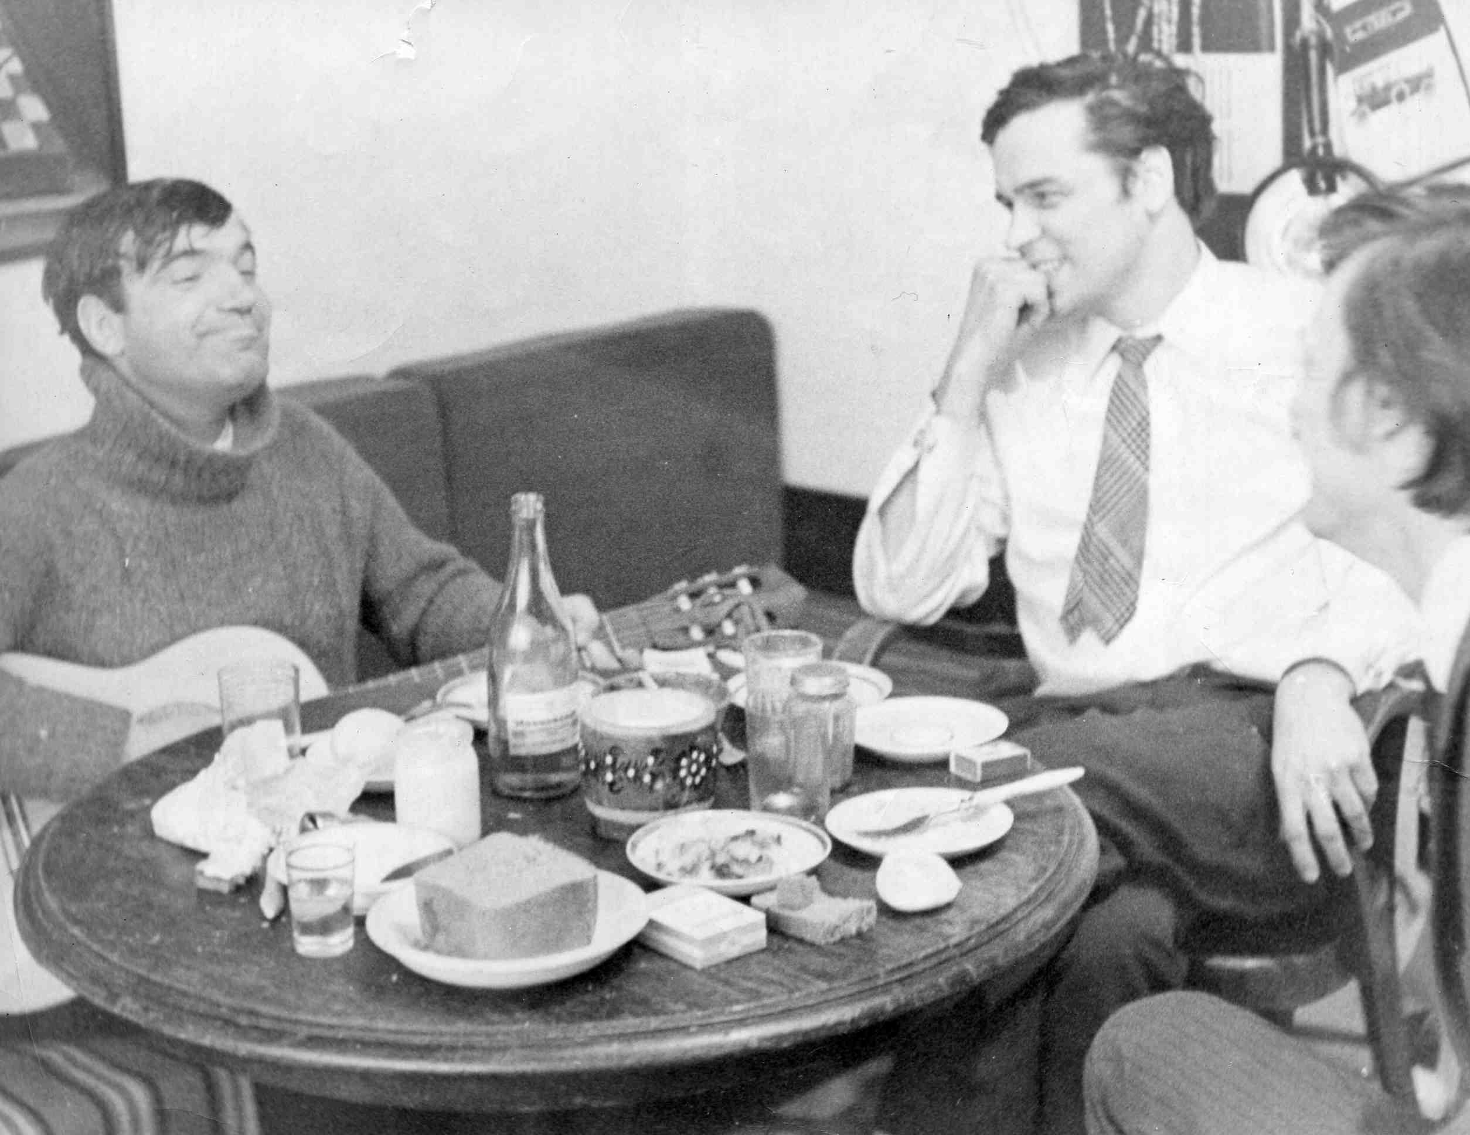  
It’s the second-to-last script by Shpalikov, the exit point, the end of an era. Considered by many to be his best work, "Jump-jump..." most clearly depicts the “Shpalikov conflict”: a story of good people who are nevertheless unbearable for each other.

**Pavel Finn**, a screenwriter and actor who graduated from the scriptwriting faculty of the State Cinema Institute (1962) and was a close friend of Gennady Shpalikov:

*But at some moment time stopped favoring Shpalikov, instead flooding his life with mercury and iron and moving further and further away from the Thaw.*

“The problem is not in the Soviet Union itself, but in our own imperfection.” – Gennady Shpalikov

“From the Lives of Planets” is a creative exploration of an anomalous period of Russian history when everything seemed full of promise. It is a story of the artist and the power, of freedom and unfreedom, of great unrealized ideas and their life after death.